**Guidewire PolicyCenter**

**Introduction to PolicyCenter**

PolicyCenter is a web-based underwriting and policy administration system designed for personal and commercial line insurers in the property and casualty insurance (P&C) industry. In PolicyCenter, producers and underwriters can submit applications, renew policies, and manage policy changes. Auditing is available for certain types of policies. PolicyCenter provides access to agents, and supports producer relationships and underwriting risk assessment. Typical users, such as underwriters and producers, can create and manage policies, service accounts, evaluate risks, view policies, create activities, and handle inquiries. PolicyCenter also provides access management tools for viewing groups and repurposing workloads.

PolicyCenter stores information about a policy and manages a set of processes that, if completed successfully, result in changes to the policy. Examples of policy changes are: creation of a new policy, renewal of a policy for a new term, or cancellation of a policy. As a result of each policy transaction (such as adding an additional driver to an auto policy), the system determines the price of the transaction. If successfully completed, PolicyCenter forwards this pricing information to a billing system. The pricing information is also important for reporting to regulators.

**The policy lifecycle**

The following diagram shows the policy lifecycle, from submission and issuance, through various policy transactions such as renewal and rewrite, to cancellation. This diagram does not display details in each policy transaction, but rather provides a high level view. You can find detailed descriptions for each policy transaction in subsequent topics.

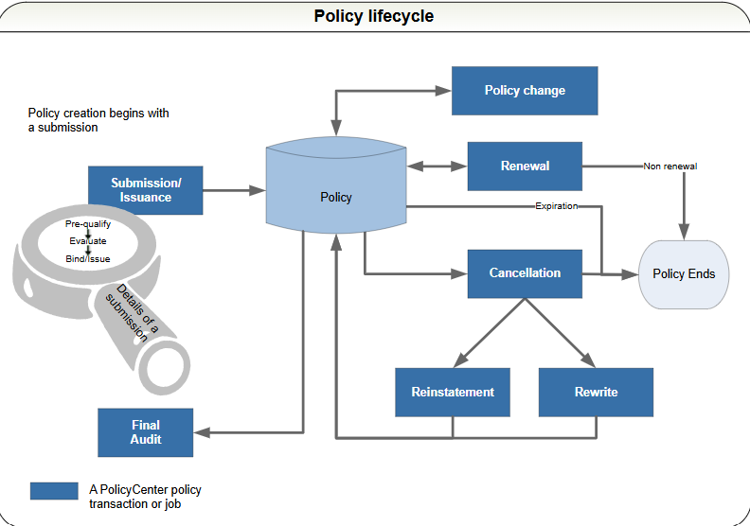

**Submission**

The goal of the submission process is for the producer to create a policy and have the policyholder accept it. The producer enters the policyholder’s information and gives a quote to the policyholder. If the policyholder agrees and accepts it, then the producer binds the policy and sends it out with the accompanying documentation. The producer also forwards the billing information to an external billing system (not shown in the diagram).

**Policy change**

If the producer makes changes to a policy, those changes may need to be evaluated by an underwriter and may result in a change to the premium. A typical change might include additions to the policy (such as adding drivers or cars) or changes to coverage limits and deductible amounts.

**Renewal**

The normal progression just before a policy expires is to renew it for another period of time – six to 12 months is typical. After PolicyCenter renews a policy, it returns the policy to maintenance mode until the policy changes, expires, cancels, or renews again.

**Cancellation and reinstatement**

You can also cancel policies. You can also rescind a cancellation before the cancellation process is complete. An example is a producer mailing a cancellation notice for non-payment to a policyholder. If the policyholder corrects this by submitting payment before the cancellation date then the cancellation can be rescinded with no break in coverage.

**Reinstatement**

Reinstatements go hand in hand with cancellations and are a type of policy change that returns a canceled policy to in-force status. The policy is in-force as of the reinstatement date. The reinstatement removes the cancellation from the policy period since the period is no longer canceled. The expiration date remains the same.

**Rewrite**

When there are many errors are on a policy, you may need to rewrite it. You must cancel the policy before it can be rewritten.

**Audit**

The audit policy transaction lets the insurer verify information about the policyholder so that they can determine the accuracy of premiums paid. The audit policy transaction provides final audit and premium reports.

PolicyCenter supports only final audit for the workers’ compensation line of business. You set up the method of final audit (physical, voluntary, or by phone) when you create the workers’ compensation policy.

With premium reports, the policyholder is billed for premium based on periodic requests for actual basis amounts, such as payroll. A deposit, usually a percentage of the estimated annual premium, is billed at the beginning of the policy. As each reporting period ends, the policyholder is billed based on the actual basis reported by them.

**PolicyCenter Users**

There are several types of users in PolicyCenter. Typically, users spend much time working on policy transactions or looking up a policy’s status to answer questions. Looking up information is relatively simple: users search for an account or a policy and view available data through the user interface. Managing policy transactions is more complex. Users initiate some transactions (for example, an agent fills out a submission to get a quote). Other transactions are a mix of automated and manual handling. For example, renewals are usually automated, but are sometimes referred to an underwriter. PolicyCenter also supports activities, notes, attached documents, history, team views, and more to help users keep track of their work, collaborate with others, and keep these processes moving.

The following table lists typical PolicyCenter users and their roles:

|  |  |
| --- | --- |
| **Users** | **Typical Activities** |
| Agents | Answer queries regarding policies |
| Submit a quote |
| Change or cancel a policy |
| Policy Service Reps | Data entry and tracking policies |
| Answer simple queries |
|  |
| Underwriters | Review accounts and policies |
| Review policy changes |
| Rewrite policies |
| Evaluate (do risk analysis on) policies and policyholders |
| Underwriting Management | Use team screens to: |
|  |
| Monitor work loads of subordinates |
| View subordinate activities |
| View polices assigned to subordinates |
| Claims staff | View policies |
| Leave notes or attach documents to accounts and policies |
| Send messages (such as a risk alert) indicating that a policy has a large loss |
| Accounting staff | View policies |
| Leave notes or attach documents to accounts and policies |
| Send messages (such as a non-renewal alert) recommending to not renew a policy due to non-payment |
| Auditors | Audit policies |
| Provide input to underwriters |

**Lines of business**

Guidewire provides line of business templates that are delivered as extension packs. Some example line of business templates are:

* Homeowners
* Personal Umbrella
* Crime
* General Liability
* Commercial Property
* Commercial Auto
* Workers’ Compensation
* Businessowners
* Inland Marine
* Personal Auto

**Personal Auto**

Most people are somewhat familiar with personal auto based on their experiences of owning a vehicle and needing insurance. Generally they know that certain parameters affect the cost of the policy, such as:

* The type of vehicle insured
* Where the driver lives
* How far the vehicle is driven in a year
* The driving record
* The gender and age of the driver
* The available discounts
* The deductible amount
* The liability limits

There are other factors that can be taken into account, such as whether the person applying for the policy already has a policy with the same insurer. During the submission process, PolicyCenter captures this information and passes it to a rating engine, which, in turn, uses the information to generate a quote. Within PolicyCenter, the Policy Info screen begins the initial capture of this information that is critical in obtaining a quote.

**Account Object Model**

The Account object model helps you to better understand the entity relationships of accounts.

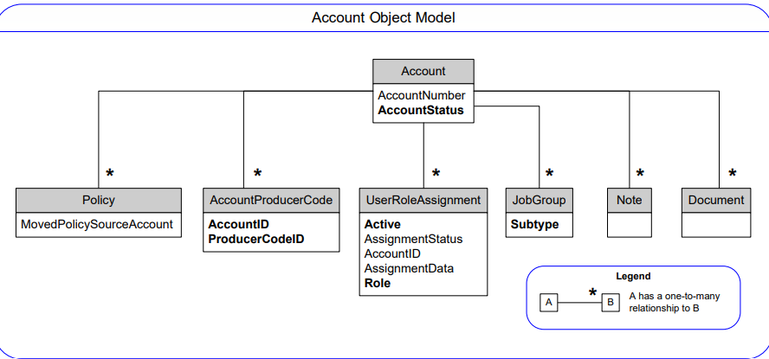

**Activity Object Model**

The following object model diagram describes key entities relating to Activity.

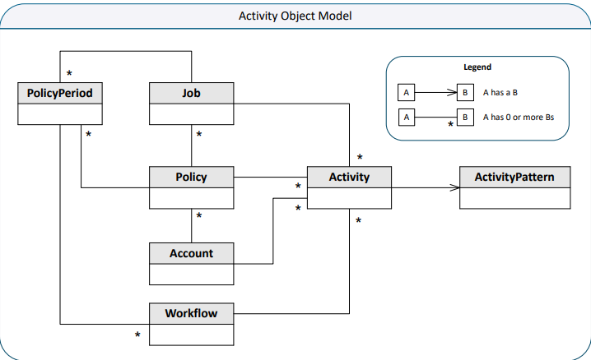

**Contact object model**

PolicyCenter stores information about the contact on the account level and the policy level.

The contact object model is designed to handle contact revisioning. The following illustration shows some the relationships of the Contact entity, using personal auto as an example. Other lines of business have the same basic entity structure with their own PolicyLine subtype and fields.

**Linked Contacts object model**

The following illustration shows some of the entities associated with contacts and linked addresses.

**Policy object model overview**

The following object model diagram shows some of the basic relationships of policy objects. This diagram focuses on the entities that interact with the Policy entity.

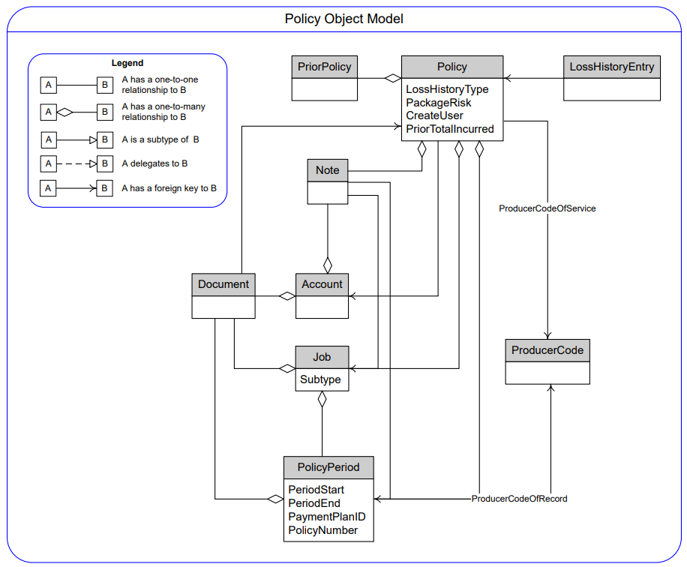

**Location object model**

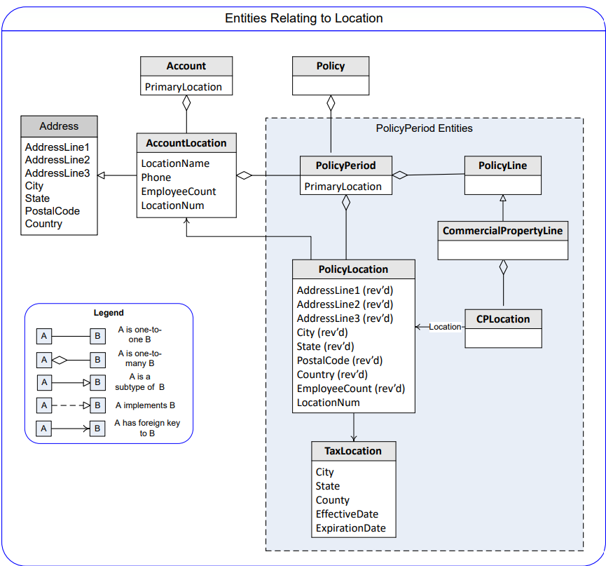

**Personal auto object model**

PolicyCenter provides a data model with entities or objects tailored to a particular line of business rather than a generic data model for all lines of business. Because PolicyCenter tailors entities to the line of business, they are easy to understand and work with. The coverage data objects for a line exist in their own database table, so you can make a change to one line of business without affecting the other lines.

The following diagram of the personal auto object model shows how some of the main personal auto entities relate to each other.

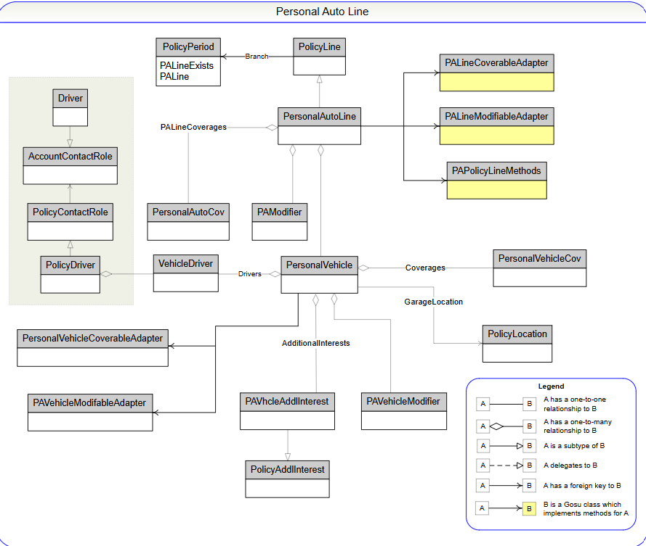

**Motor vehicle record object model in personal auto**

In personal auto, objects associated with motor vehicle records occur in three places in PolicyCenter:

• At the system level

• At the account level

• At the policy level

The following illustration shows the object model for entities related to motor vehicle records at the system level. These are the entities created when the agent orders and receives an MVR report from the service provider.

